
SRM Institute of Science and Technology
Mode of Exam
OFFLINE
College of Engineering and Technology
School of Computing
DEPARTMENT OF COMPUTING TECHNOLOGIES
SRM Nagar, Kattankulathur – 603203, Chengalpattu District, Tamilnadu
Academic Year: 2023-2024 (ODD) Batch 2 – SET A
Test: CLAT-1 Date: 9/8/2023 Course Code & Title:18CSE458T/Wireless and Mobile Communication Duration: 50 Mins
Year & Sem: VII Max. Marks: 25

Course Articulation Matrix:
CO/PO | PO1 | PO2 | PO3 | PO4 | PO5 | PO6 | PO7 | PO8 | PO9 | PO10 | PO11 | PO12 | PSO1 | PSO2 | PSO3
CO1 | 3 | 2 | - | - | - | - | - | - | - | - | - | - | - | - | -
CO2 | 2 | - | - | - | - | - | - | - | - | - | - | - | - | - | -
CO3 | 2 | - | - | - | - | - | - | - | - | - | - | - | - | - | 2
CO4 | 3 | - | 1 | - | - | - | - | - | - | - | - | - | - | - | -
CO5 | 3 | 1 | 2 | - | - | - | - | - | - | - | - | - | - | - | -

Part - A
(5 x 1 = 5 Marks)
Instructions: Answer all
Q. No | Question | Marks | BL | CO | PO | PI Code
1 | In Which of the following, the single-Channel has the ability to carry all transmissions simultaneously  A. CDMA  B. TDMA  C. FDMA  D. None of the above  Ans: A | 1 | 1 | 1 | 1 | 1.6.1
2 | Which of the following statements about the Half duplex is correct?  A. It is a type of communication in one direction  B. It is a type of communication in one direction at a time  C. It is a type of communication in Bi- direction at the same time  D. None of the above.  Ans: B | 1 | 1 | 1 | 1 | 1.6.1
3 | Which of the following is the result of over modulation  A. Weakening of signal  B. Distortion  C. Strengthening of signal  D. Excessive carrier power  Ans: B | 1 | 1 | 1 | 1 | 1.6.1
4 | DSSS system spreads the baseband signal by ____ the baseband pulses with a pseudo noise sequence.  A. Adding  B. Subtracting  C. Multiplying  D. Dividing  Ans: C | 1 | 1 | 1 | 1 | 1.6.1
5 | Frequency hopping involves a periodic change of transmission______  A. Signal  B. Frequency  C. Phase  D. Amplitude  Ans: B | 1 | 1 | 1 | 1 | 1.6.1
Part B
(5 X 2 = 10 Marks)
1 | What are all the elements of Communication Systems?  - Sending and Receiving Devices  - Communication Channel  - Connection Devices  - Data Transmission specifications | 2 | 1 | 1 | 1 | 1.6.1
2 | State the different types of Communication Systems with suitable example.  - Simplex  - Half-duplex  - Full-duplex | 2 | 2 | 1 | 1 | 1.6.1
3 | Define Noise with suitable Illustration.  Noise is an unwanted signal, which interferes with the original message signal and corrupts the parameters of the message signal.  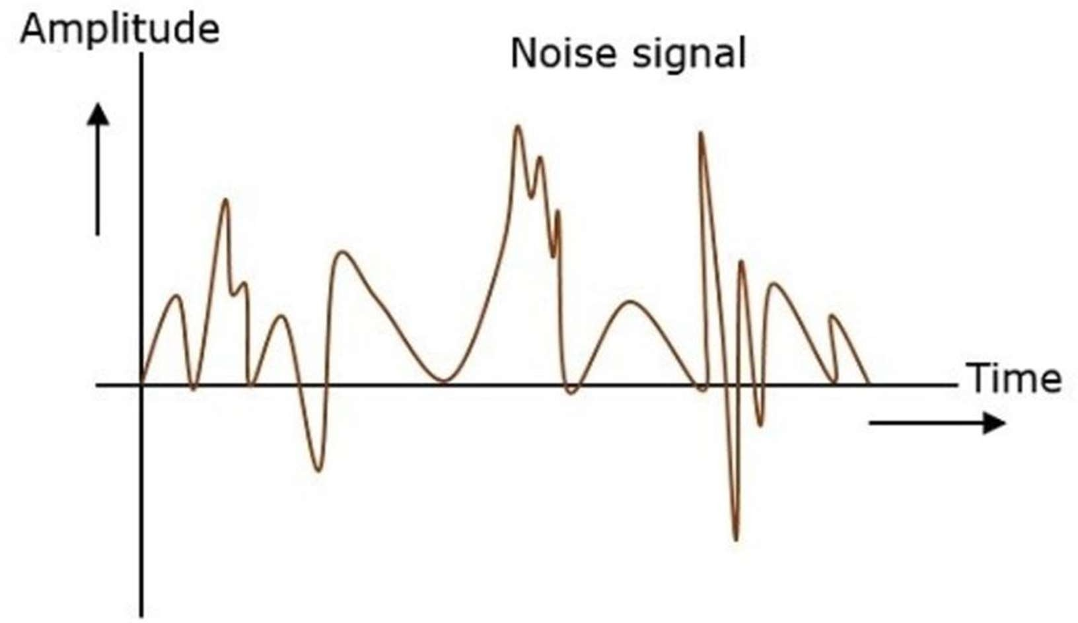 | 2 | 1 | 1 | 1 | 1.6.1
4 | Define Modulation Index.  A carrier wave, after being modulated, if the modulated level is calculated , then such an attempt is called as Modulation Index or Modulation depth. | 2 | 1 | 1 | 1 | 1.6.1
5 | Mention the differences between TDMA, FDMA, and CDMA.  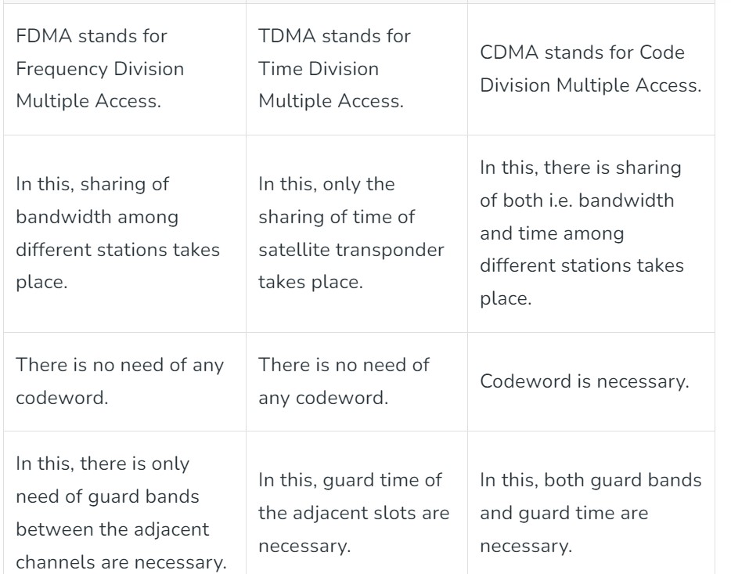 | 2 | 2 | 1 | 1 | 1.6.1
Part – C
( 1 x 10 =10 Marks)
Instructions: Answer any one
6 a.  b. | How the communication channels are multiplexed? Explain different types of Multiplexing with suitable Illustration.  - FDM  - TDM  - CDM  Frequency Division Multiplexing  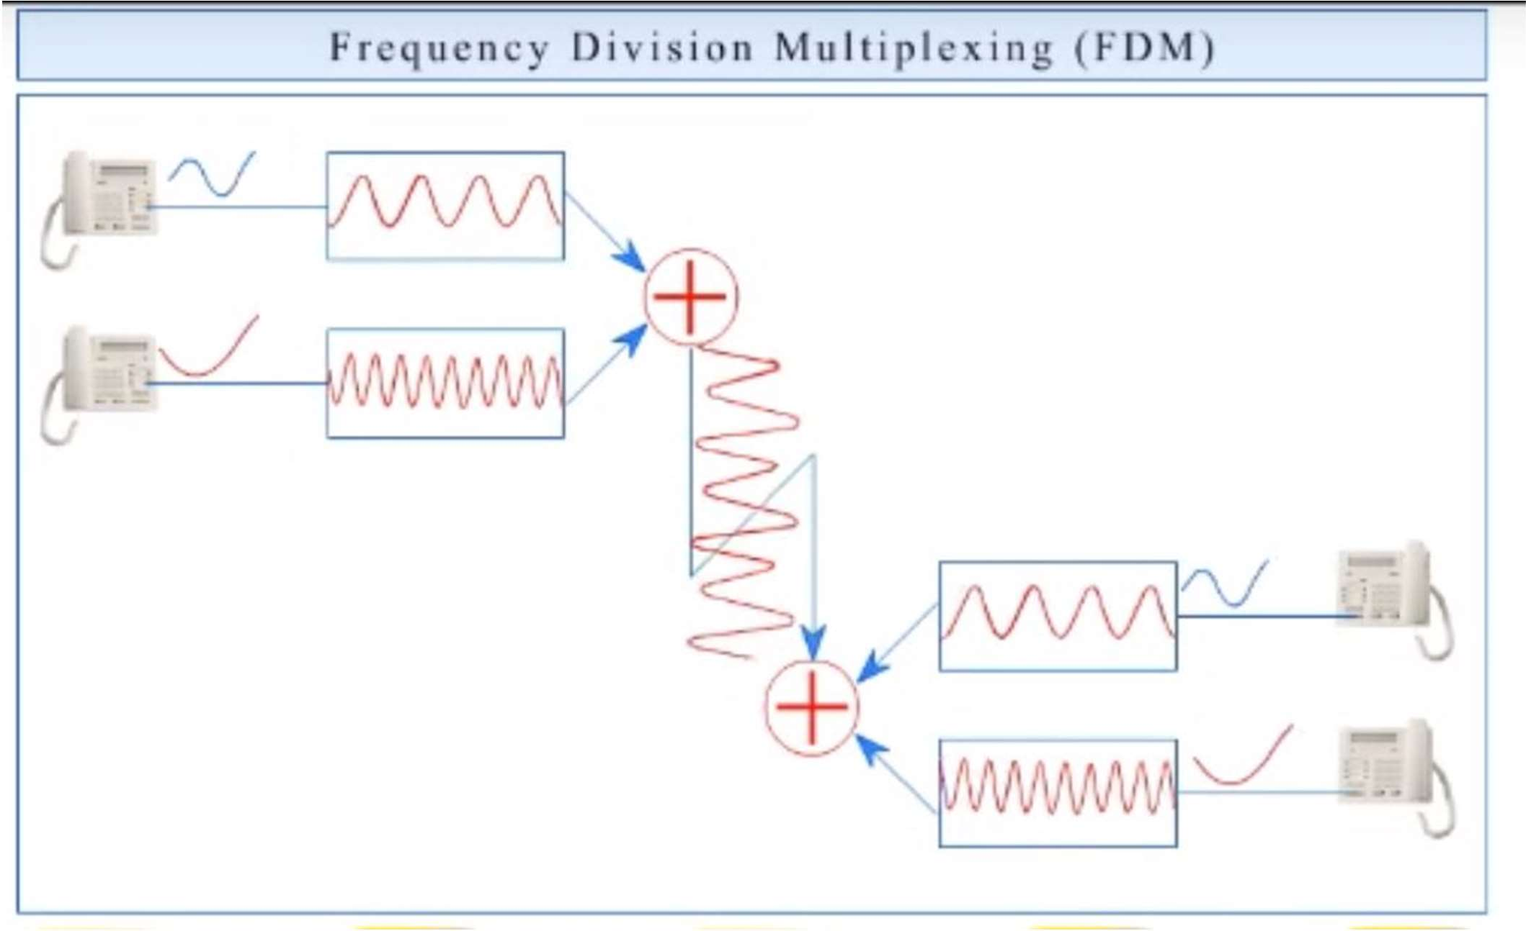  Time Division Multiplexing  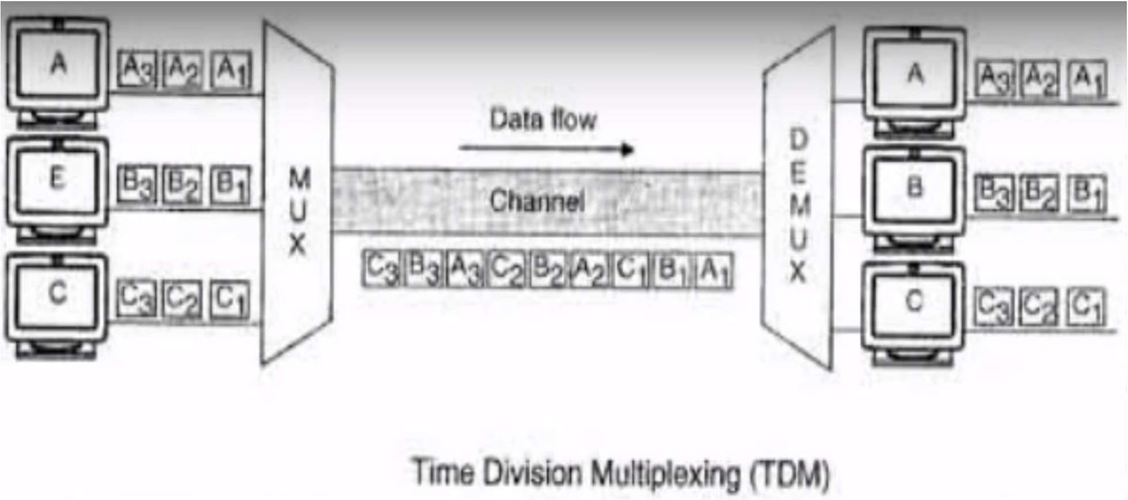  Code Division Multiplexing  CDM is a fixed assignment access technique that uses spread spectrum and special kind of coding scheme to allow the transmitter to share the media at the same time.  (or)  Illustrate Direct Sequence spread spectrum with necessary diagram.  Combine input with spreading code using XOR  Input bit 1 inverts spreading code bit  Input zero bit doesn’t alter spreading code bit  Data rate equal to original spreading code  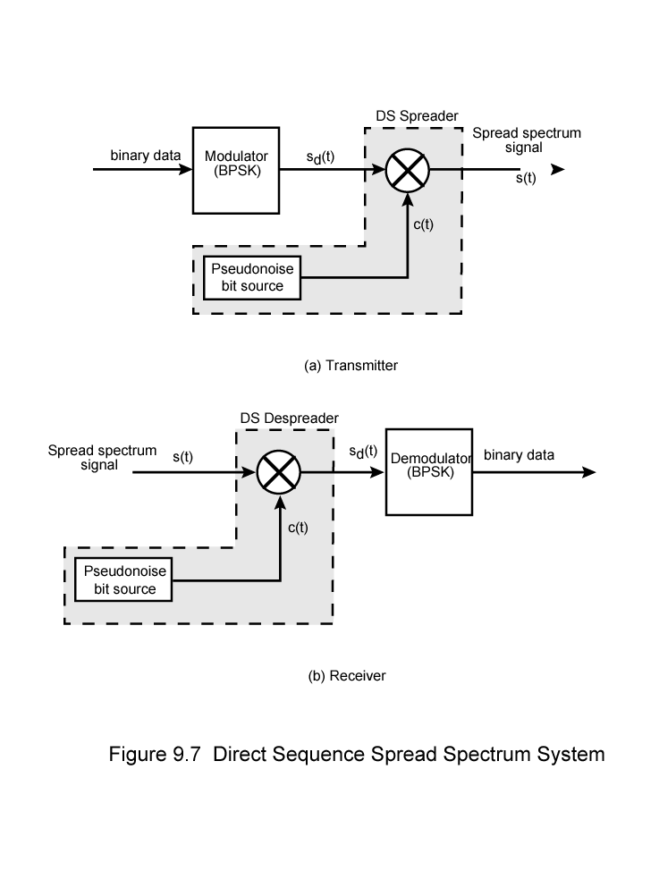 | 10 | 2 | 1 | 1 | 1.6.1

Course Outcome (CO) and Bloom’s level (BL) Coverage in Questions
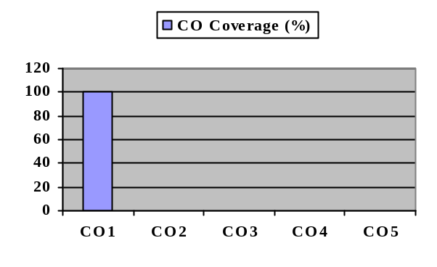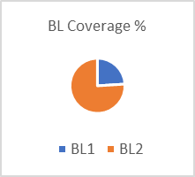

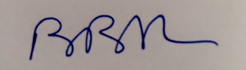

Approved by the Audit Professor/Course Coordinator

